**PRACTICAL NO.7**

**Programs on Intents, Events, Listeners and Adapters**

The Android Intent Class, Using Events and Event Listeners

**Code:**

**activity_main.xml**

<?xml version="1.0" encoding="utf-8"?>  
<androidx.constraintlayout.widget.ConstraintLayout xmlns:android="http://schemas.android.com/apk/res/android"  
 xmlns:app="http://schemas.android.com/apk/res-auto"  
 xmlns:tools="http://schemas.android.com/tools"  
 android:layout_width="match_parent"  
 android:layout_height="match_parent"  
 tools:context=".MainActivity">  
  
 <EditText  
 android:id="@+id/user_data"  
 android:layout_width="match_parent"  
 android:layout_height="wrap_content"  
 android:layout_marginStart="32dp"  
 android:layout_marginEnd="32dp"  
 android:ems="10"  
 android:hint="User data"  
 android:inputType="textPersonName"  
 app:layout_constraintBottom_toBottomOf="parent"  
 app:layout_constraintEnd_toEndOf="parent"  
 app:layout_constraintHorizontal_bias="0.402"  
 app:layout_constraintStart_toStartOf="parent"  
 app:layout_constraintTop_toTopOf="parent"  
 app:layout_constraintVertical_bias="0.069" />  
  
 <Button  
 android:id="@+id/button"  
 android:layout_width="wrap_content"  
 android:layout_height="wrap_content"  
 android:text="Submit"  
 app:layout_constraintBottom_toBottomOf="parent"  
 app:layout_constraintEnd_toEndOf="parent"  
 app:layout_constraintHorizontal_bias="0.899"  
 app:layout_constraintStart_toStartOf="parent"  
 app:layout_constraintTop_toTopOf="parent"  
 app:layout_constraintVertical_bias="0.155" />  
  
 <Button  
 android:id="@+id/button2"  
 android:layout_width="wrap_content"  
 android:layout_height="wrap_content"  
 android:text="Go"  
 app:layout_constraintBottom_toBottomOf="parent"  
 app:layout_constraintEnd_toEndOf="parent"  
 app:layout_constraintHorizontal_bias="0.9"  
 app:layout_constraintStart_toStartOf="parent"  
 app:layout_constraintTop_toTopOf="parent"  
 app:layout_constraintVertical_bias="0.349" />  
  
 <EditText  
 android:id="@+id/url_text"  
 android:layout_width="match_parent"  
 android:layout_height="wrap_content"  
 android:layout_marginStart="32dp"  
 android:layout_marginEnd="32dp"  
 android:ems="10"  
 android:hint="Enter Url .."  
 android:inputType="textPersonName"  
 app:layout_constraintBottom_toBottomOf="parent"  
 app:layout_constraintEnd_toEndOf="parent"  
 app:layout_constraintHorizontal_bias="0.388"  
 app:layout_constraintStart_toStartOf="parent"  
 app:layout_constraintTop_toTopOf="parent"  
 app:layout_constraintVertical_bias="0.268" />  
  
 <Button  
 android:id="@+id/button3"  
 android:layout_width="wrap_content"  
 android:layout_height="wrap_content"  
 android:text="Long Press"  
 app:layout_constraintBottom_toBottomOf="parent"  
 app:layout_constraintEnd_toEndOf="parent"  
 app:layout_constraintStart_toStartOf="parent"  
 app:layout_constraintTop_toTopOf="parent"  
 app:layout_constraintVertical_bias="0.499" />  
  
 <ImageView  
 android:id="@+id/imageView"  
 android:layout_width="wrap_content"  
 android:layout_height="wrap_content"  
 app:layout_constraintBottom_toBottomOf="parent"  
 app:layout_constraintEnd_toEndOf="parent"  
 app:layout_constraintStart_toStartOf="parent"  
 app:layout_constraintTop_toTopOf="parent"  
 app:layout_constraintVertical_bias="0.667"  
 app:srcCompat="@drawable/ic_launcher_background" />  
</androidx.constraintlayout.widget.ConstraintLayout>

**MainActivity.kt**

package com.example.mydemo  
import android.content.Intent  
import android.net.Uri  
import androidx.appcompat.app.AppCompatActivity  
import android.os.Bundle  
import android.view.KeyEvent  
import android.view.MotionEvent  
import android.widget.Toast  
import kotlinx.android.synthetic.main.activity_main.*  
  
class MainActivity : AppCompatActivity() {  
 override fun onCreate(savedInstanceState: Bundle?) {  
 super.onCreate(savedInstanceState)  
 setContentView(R.layout.activity_main)  
 button.setOnClickListener {  
 var userdata=user_data.text  
 var compose=Intent(Intent.ACTION_SEND)  
 compose.putExtra(Intent.EXTRA_TEXT,userdata)  
 compose.type="text/plain"  
  
 var sendOptions=Intent.createChooser(compose,"msg")  
 startActivity(sendOptions)  
 }  
  
 button2.setOnClickListener {  
 var url=url_text.text  
 var siteData=Intent(Intent.ACTION_VIEW)  
 siteData.setData(Uri.parse("$url"))  
 startActivity(siteData)  
 }  
  
 button3.setOnLongClickListener {  
 Toast.makeText(this,"Long Click event occurs!!!",Toast.LENGTH_SHORT).show()  
 true  
 }  
  
 imageView.setOnTouchListener { view, motionEvent ->  
 when(motionEvent.action)  
 {  
 MotionEvent.ACTION_DOWN -> Toast.makeText(this,"TouchListener - Action Down event occurs!!!",Toast.LENGTH_SHORT).show()  
 MotionEvent.ACTION_UP -> Toast.makeText(this,"TouchListener - Action Up event occurs!!!",Toast.LENGTH_SHORT).show()  
 MotionEvent.ACTION_POINTER_DOWN -> Toast.makeText(this,"TouchListener - Action Pointer Down event occurs!!!",Toast.LENGTH_SHORT).show()  
 }  
 true  
 }  
  
 user_data.setOnKeyListener { view, i, keyEvent ->  
 if (keyEvent.keyCode == KeyEvent.KEYCODE_ENTER)  
 {  
 Toast.makeText(this,"Enter key pressed !!!",Toast.LENGTH_SHORT).show()  
 }  
 true  
 }  
 }  
}

**Output:**

**Within an Application(Intent)**

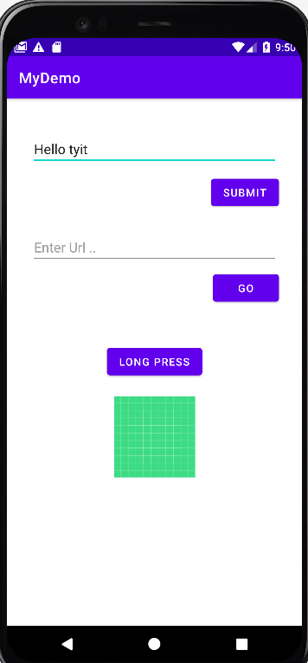 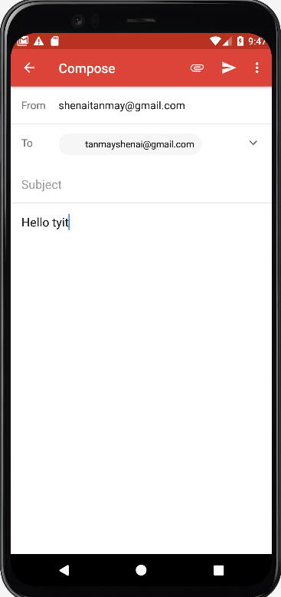

**Enter Key Event & Long click event :**

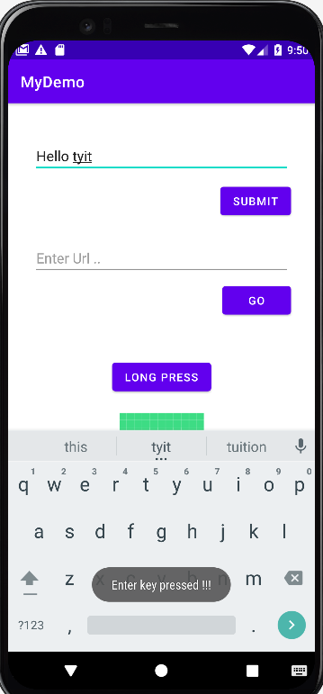 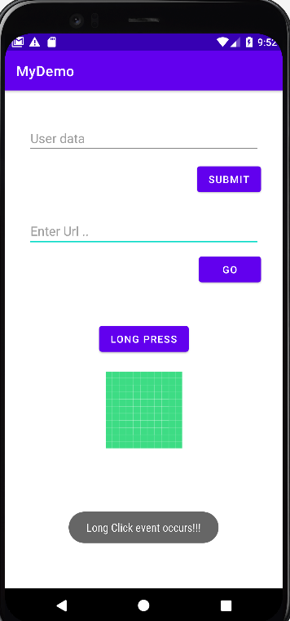

**Outside an Application(Intent)**

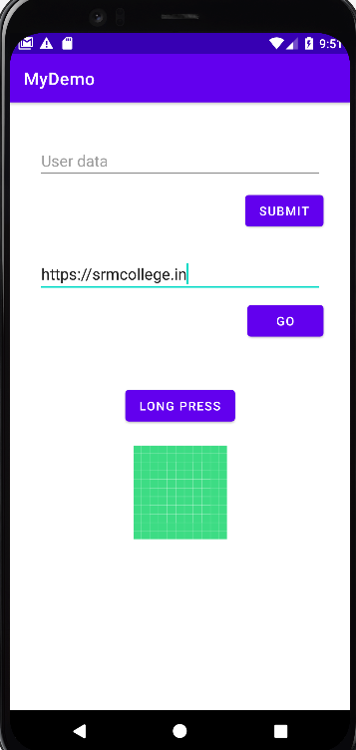 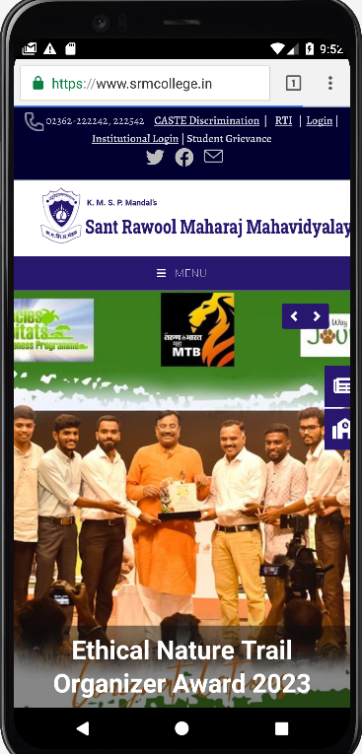

**TouchListener-Action_down & Action_up :**

